Renewable Energy Project
Final Report

Michael Horn
Garrett Cornelius
Nicholis Santana
Issac Granados
SPRING-FALL 2023


Northern Arizona University
Department of Mechanical Engineering

Project Sponsor: Steve Wineicki
Faculty Advisor: Dr. Carson Pete

DISCLAIMER
This report was prepared by students as part of a university course requirement. While considerable effort has been put into the project, it is not the work of licensed engineers and has not undergone the extensive verification that is common in the profession. The information, data, conclusions, and content of this report should not be relied on or utilized without thorough, independent testing and verification. University faculty members may have been associated with this project as advisors, sponsors, or course instructors, but as such they are not responsible for the accuracy of results or conclusions.

EXECUTIVE SUMMARY

Introduction

This report is a culmination of the work completed by the Renewable Energy Capstone Project team, for ME 476c at Northern Arizona University, for the Department of Mechanical Engineering. This required course allows engineering students to engage in the engineering process in a controlled environment, with the guidance of professors and peers. The capstone process requires students to conduct research, testing, reports, and the overall implementation of a large scale project with a preallocated budget.

Project Description

Mr. Steve Winiecki, the client for this project, requests that the team design, optimize, and implement a solar photovoltaic (PV) system. The system is to be capable of both off grid and grid tied use, in order to generate power for his off grid cabin located in Camp Verde, Az; this functionality is known as a hybrid solar system. The system is to be safe, efficient, adaptable, and must minimize feedback into the grid.

Design Solution

The proposed solution and final design is Design 2. This design has been deliberated upon in previous deliverables, but will be expanded upon within this report, in Section 6. Conclusion. This design incorporates cost effective and efficient materials, and meets all of the customer requirements. A decision matrix used in determining this design is located in Appendix XV, along with a full Bill of Materials located in Appendix XI. An electrical diagram of this system is located in Figure 1.

TABLE OF CONTENTS
DISCLAIMER 1
EXECUTIVE SUMMARY 2
1. Background 5
1.1. Introduction 5
1.2. Project Description 5
1.3. Original System 5
1.3.1. Original System Structure 5
1.3.2. Original System Operation 6
1.3.3. Original System Performance 6
1.3.4. Original System Deficiencies 6
2. Requirements 7
2.1. Customer Requirements 7
2.2. Engineering Requirements 8
2.3. Functional Decomposition 9
2.3.1. Black Box Model 9
2.3.2. Functional Model / Work-Process Diagram 10
2.3. House of Quality 11
2.4. Standards Codes and Regulations 12
3. Testing Procedures 13
3.1. Testing Procedure 1: Metering 13
3.1.1. Testing Procedure 1: Objective 14
3.1.2. Testing Procedure 1: Resources Required 14
3.1.3. Testing Procedure 1: Schedule 14
4. Risk Analysis and Mitigation 15
4.1. Critical Failures 15
4.1.1. Potential Critical Failure 1: Solar Panel failure 15
4.1.2. Potential Critical Failure 2: Ground Mounting Kit Yield 15
4.1.3. Potential Critical Failure 3: Concrete Footing Failure 15
4.1.4. Potential Critical Failure 4: Inverter Failure 16
4.1.5. Potential Critical Failure 5: Display and Controller Failure 16
4.1.6. Potential Critical Failure 1: Battery Failure 16
4.1.7. Potential Critical Failure 7: Cable Failure 16
4.1.8. Potential Critical Failure 1: Conduit and J box Failure 17
4.2. Potential Non-Critical Failures 17
4.2.1 Non-Critical Failure 1: Snow Accumulation 17
4.2.2. Non-Critical Failure 2: Extreme Energy Draw 17
4.3. Risks and Trade-offs Analysis 18
5. Designs Selected 18
5.1. Design Description 18
5.1.1. Main Design Components 18
5.1.1.1. Inverter 19
5.1.1.2. Solar Panels 19
5.1.1.3. Batteries 19
5.1.1.4. Grid Power 19
5.1.1.5. Complementary Components 20
5.1.2. Relevant Calculations 20
5.1.3. Prototyping 20
5.1.3.1. Physical Prototyping 20
5.1.3.2. Digital Prototyping 21
5.2. Design Validation 21
5.3. Implementation Plan 23
5.3.1. Preliminary Steps 23
5.3.2. Implementation Procedure 24
5.3.2.1. Client Contact/ Budget Considerations 24
5.3.2.2. Material Sourcing 24
5.3.2.3. Implementation Costs 24
5.3.2.4. Scheduling 24
6. Conclusion 25
6.1. Report Summary 25
6.1.1. Project Description 25
6.2. Final Solution Proposal - Full System Design 2 25
7. References 26
8. Appendices 28
Appendix I: Original System Spec Sheets 28
Appendix II: Original Bill of Materials 32
Appendix III: Original System PVWatts Report 33
Appendix IV: Original System Quotes 34
Appendix V: Renewable Energy Systems Pugh Chart 36
Appendix VI: Back-of-the-Envelope Calculations 36
Appendix VII: Black Box Model 37
Appendix VIII: Work Process Chain Diagram 37
Appendix IX: House of Quality 38
Appendix X: Detailed Electrical Diagram Displaying Inverter 39
Appendix XI: Final Design Bill of Materials 40
Appendix XII: Trina Tallmax Spec Sheet 41
Appendix XIII: FMEA for Design 2 43
Appendix XIV: Select Prototyping Photos 44
Appendix XV: Final Design Decision Matrix 45
Appendix XVI: Energy Model Electricity Consumption Results 46
Appendix XVIII: Cooling & Heating Consumption Results 47
Appendix XIX: Heating and Cooling Load Model Results 48

1. Background

1.1. Introduction
This document is a preliminary report detailing the initial stages of the Renewable Energy Project. The processes of problem identification, determining customer and engineering requirements, literary research, system benchmarking, concept generation, and final design selection are included within this document. This document is a critical step in an expansive and detailed project, which will involve several more intermediary stages and deliverables. Technical analysis to include energy modeling, structural analysis, wind projections, and load analysis will be the next initial steps, following a formal presentation of this report. Prototyping, testing, material procurement, and construction will follow within the final stages of the project.

1.2. Project Description
The stakeholder and client, Mr. Steve Winiecki, will be constructing an off-grid cabin in Camp Verde, Az. This cabin will act as a permanent residence for him and his family. Construction plans are already completed, however power generation has not been acquired. It is the Renewable Energy Team’s responsibility to design and oversee the implementation of a power generation system; this system will consist of a solar photovoltaic (PV) system. The customer and engineering requirements are detailed below in section 2. Requirements.

1.3. Original System
This project is based on work previously completed by a group of ME 451 Renewable Energy students. The completed work includes a final report, consisting of a site layout, bill of materials, and warranty information. Previously completed HVAC and construction plans for the cabin are available to the team, which include engineering drawings and descriptions. Information about the thermal properties of the cabin is not provided, however information regarding the HVAC loads is present. A zip folder containing datasheets for many components is also provided. These data sheets may be located in Appendix I.

1.3.1. Original System Structure
One of the customer requirements is for the system to be capable of utilizing power from the grid, and power generated by the PV system. The client specifically requested that the system is capable of eliminating any feedback into the grid, during times of excess PV power generation. In order to achieve this, a specialized inverter is necessary. The FLEXpower Radian GS8048-A-01 is equipped with programmed settings which prevent feedback for grid tied systems, while still allowing the user to draw from the grid. Although no electrical diagrams of the system are provided by the previous team, the system structure will be based on the needs and configuration of this inverter. A basic diagram depicting the most simple configuration for this inverter is shown in Figure 1.

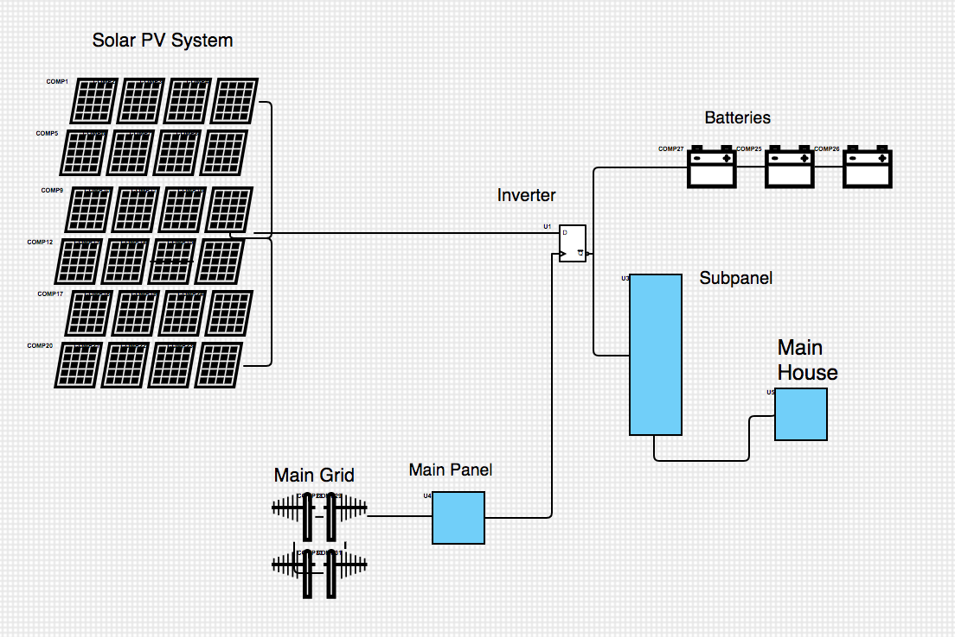
Figure 1: Basic Electrical Diagram for FLEXpower Radian A

1.3.2. Original System Operation
The original system operates using a specialized inverter, known as the Outback Radian A series. This inverter is equipped with “GridZero” mode, which enables the user to draw power from both the grid and an additional AC power source, without backfeeding into the grid. This system would utilize a fixed tilt angle, ground mounted solar array, equipped with Q.Peak Duo BLK 365 solar panels. A complete bill of materials for this system is located in Appendix II.

1.3.3. Original System Performance
Using the National Renewable Energy Laboratories online PVWatts calculator, this system can be estimated to produce about 15,099 kWh/ year of energy. A summary of this calculation can be found in Appendix III.

1.3.4. Original System Deficiencies
The most prioritized deficiency of this system is the cost. As well as technical documents, two quotes from solar companies are provided by the previous team students, which can be accessed in Appendix IV. These quotes far exceed the client’s budget, preventing the project from completion. The current team is invested in procuring the most economically efficient materials possible, while retaining adequate quality.

2. Requirements
The initial proposal that comes from the client gives the team a foundational groundwork requirements to build off of. Once the evaluation of these requirements are finalized, the team then sets up their own criteria of how each requirement will be met. Each requirement will have its own value of importance and determining how to move from there will be discussed within a later section of this document.

2.1. Customer Requirements
Upon speaking with the customer, a few key elements were communicated right away. Our grade scale is on a 1-5 point scale, 1 being the least of customer concerns and 5 being the highest. Down below is the team's customer requirements with its scale value attached.
* Cost Efficient - 3
* Large Storage System - 4
* Reliable/Adaptable Design - 4
* Solar Generation Heavy - 5
* Safe to operate - 5
Having a cost efficient system is scaled at a midpoint value based on our customer’s requests in the way that he wants to set up his system. As he understands that the cost of the system will be expensive he has given the team a range of costs that he would be willing to spend compared to the cost that he is hoping to spend.
The team’s client is hoping to create an off-grid system which would rely solely on the solar generators that would create electricity throughout his house. He will need to have an adequate store system capable of retaining some of that power for later use when the sun isn’t present. Since he will be having the option to take power from the grid in the event of an emergency his storage system isn’t one of the highest requirements.
Although the client’s house will run from an off-grid system, the option of taking power from the grid will be put in place just in case of emergencies. However, since the client is going to do what he can to not rely on the grid, this requirement isn’t placed on the highest scale level.
With any off-grid system, the energy being produced from outside sources is the top priority of that system. The team’s client wants the option of a full off-grid system which means the solar generation that will be generated daily will be one of the main priorities for the client and the team.
Within every engineering field having a safe, reliable and adaptable system is essential for any product being made. The team also has to take into consideration the laws and regulations of the area that this solar system is being built on so that the grid tied company that the client will be connected with, won’t deconstruct the system and reconstruct it back to code.

2.2. Engineering Requirements

As the team evaluated the Customer Requirements, the same amount of engineering requirements are in place as shown below. With each requirement that is shown, not all requirements have a positive impact on the others. Each requirement is listed below along with its targeted requirements as well as the tolerances.
* Decrease Design Cost $35,000 $-$10,000
* Increase Efficiency 2.99 $/W$\frac{+}{-}$.5
* Increasing Generation 30 kWh/month $\frac{+}{-}$3
* Increase Storage 15 kWh $+$5
* Increase Adaptability 3 units +2
With the budget for this project having a varying range, the team has decided to aim for the smallest amount of cost for the client with an understanding that certain items may be more expensive based on the quality of products, failed tests, and degradation of the system overtime. In order for the team to minimize the cost of the design, looking at a long term timeline and understanding the replacement costs are taken into account. The targeted value for the cost is around 35,000 dollars with a negative 10,000 dollars if possible.
The house itself also holds a role in the way that energy is saved. The installation process of the house will be a determining factor of the amount of energy needing to be produced on a daily basis. If the installation process has high marks, the energy that is being produced will be able to be more efficient in other areas of the house and vice versa if the process is poor. Another factor that can play a part within the efficiency would be the angle of tilt of the solar panels. The targeted value for the efficiency is 2.99 dollars per Watts with a positive or negative 0.5 tolerance.
The positioning of the solar panels does determine how much generation of electricity will be produced. By understanding the best angle to place a solar panel throughout the year will give the user the most generation from the system. The type of panels used within the system also plays a part when taking into account the losses of that generation process. The targeted value for the energy generation is 30 kilo-Watt-hours per month with a tolerance of positive or negative 3.
As the client doesn’t want to rely on the grid, a battery system is a needed aspect within the project. Being able to utilize the extra generation of the solar panels at a later time is very beneficial to the client when the sun sets and he will be reliant on that leftover energy until the panels generate more power the following day. In many instances having a backup storage unit of a minimum of 3 day usage is recommended for any off grid system. With that in mind, the team needs to locate the best quality, at a reasonable cost, battery storage unit that will give its user a 3 day lifespan if no generation from the solar panels are being produced. The targeted value for energy storage is 15 kilo-watt-hours with a positive 5 tolerance.
With a hybrid system the components of incorporating the electrical company and their policies will be followed to a degree. Since the client doesn’t want to back feed his solar generation to the grid the safety measures for the electric company isn’t as big of a problem since power will not be constantly going to and from the house. If the electric company, for whatever reason, needs to shut off the power being provided to its clients, the team’s client will not be affected by the shut off switch and would still be able to use his own power that has been generated with the solar panels. The targeted value for the amount of sources of energy being directed to the house is 3 with a tolerance of positive 1.

2.3. Functional Decomposition

The purpose of the functional decomposition is to break the entire design challenge into small-scale solutions. Decomposing and dissecting the design increases clarity on the engineering requirements and goals to outline a baseline functionality of the design and highlight interactions between subsystems. A hybrid PV system and its subsystems combine to create a complex network of energy and signal flows. To simplify the design, the team has employed two levels of functional decomposition: a black box model and a function chain diagram. The black box model is the most simplified decomposition as it focuses directly on the inputs and outputs of the system. It demonstrates that the design ultimately transfers energy from one location to another. The function chain diagram elevates the level of detail by creating a map of signal and energy flows between the subsystems within the design.

2.3.1. Black Box Model

The black box model depicted below in Figure 2 (Appendix VII) shows the appropriate inputs and outputs for our overall solar system. There are no physical material inputs or outputs for our system. Our system is based on energy and signal inputs and outputs only. The main inputs and outputs for our system are energy. For a renewable energy solar system, solar energy is the dominant input and source. As shown above, the dominant input of the system is solar photons. The Solar photon input then directly outputs to either battery electrons or an AC to power the house.

The grid electrons are also an input to our system. Once the solar energy has been transferred into energy, the grid can input this energy to output AC loads to the house. The AC loads are the exact desired output of the overall system.This output will ultimately be the desired output and use that the client requires from the system .

The final input to the system is an AC/DC signal. This is the only signal input for our system and the only non energy input for our system. This signal comes from any signal in the clients house (ex. A light switch). This signal input will be the catalyst that starts the energy transfer from the grid to the house. Because the house is the final destination for the power, there is no output signal in our system.
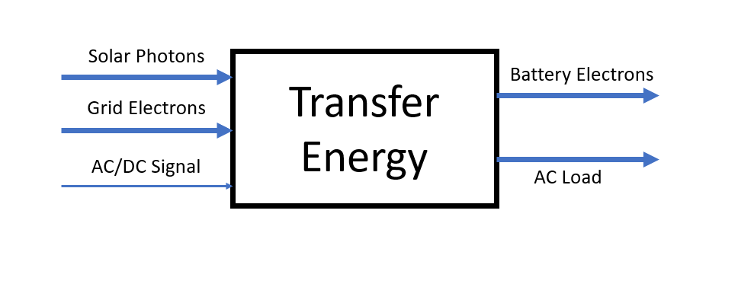
Figure 6: Black Box Model

2.3.2. Functional Model / Work-Process Diagram

A functional model is used to loosely define the overall process that the device will be subjected to during normal operation. It is designed to show the flow of inputs, outputs, and operations between subsystems and components so the team can have a simplified view on what the design is accomplishing at any given point. This simplification allows the team to be more effective and creative when implementing and designing small-scale solutions between each step.
The benefit of having a hybrid PV system comes from the varying forms of energy that can be used to power the home. However, it adds a layer of difficulty because the system needs to be self sufficient at managing these power inflows and directing the most efficient method into the home. This decomposition also includes several subsystems such as the panels, storage bank, and battery controller. Below in Figure 3 (Appendix VIII) is a functional chain that describes the process of the hybrid PV system and how the system will need to manage the flow of electricity. The chain’s arrows depict the flow of electricity and the dashed lines depict a signal transfer. This diagram demonstrates the flow of energy once a load is detected by the system and the multitude of paths that the electricity can take depending on the originating signal. In our system, the start of the transfer of electricity is signaled by an electrical need from the house. It is then up to the system and battery controller to determine the source of the power needed. The electricity could be sourced from the panels, the battery storage bank, or the grid depending on the states of each source. For example, if the sun has set and the panels are not generating any power, then the controller will source the power from the battery bank. However, If the battery bank is depleted then the system will source the needed electricity using grid power as a last resort.

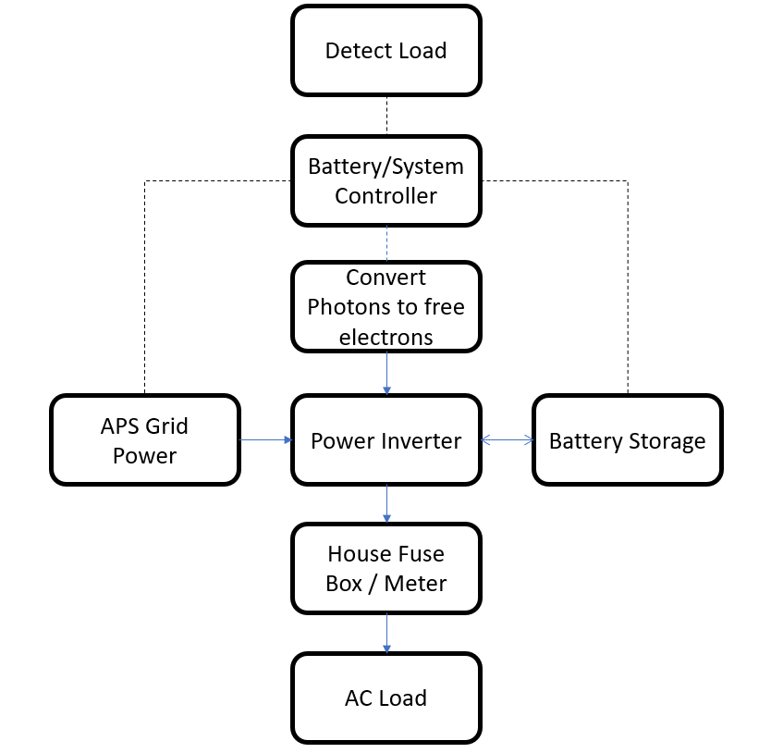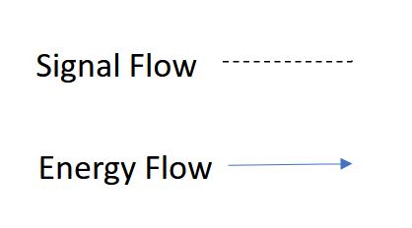

Figure 7: Work Process Chain Diagram

2.3. House of Quality
Taking the information from above, the team constructed a House of Quality document that states the importance of what the customer is asking for along with the improvements that the team can provide. As stated above the Customer’s Requirements and the Engineering Requirements with their targeted values are as follows:

- Cost Efficient 3 1. Decrease Design Cost $35,000
- Large Storage System 4 2. Increase Storage 2.99 $/W
- Safe to Operate 5 3. Increase Safety 30 kWh/month
- Solar Generation Heavy 5 4. Increase Generation 15 kWh
- Reliable/Adaptable Design 4 5. Increase Efficiency 3 units

The full House of Quality can be seen in Appendix IX

2.4. Standards Codes and Regulations

Under standard conditions in the private sector, licensed solar design and installation companies are legally obligated to adhere to federal, state, and local standards. These standards and codes are implemented to ensure the safety of consumers, contractors, and the general public by preventing subpar workmanship and unsafe installation practices. For this particular project involving a privately owned home, compliance with various codes and regulations is necessary, including electrical codes, building codes, fire codes, and permit regulations. Local and federal regulations must be followed if the homeowner wishes to avail themselves of government incentives and incentives. It is worth mentioning that, in this case, the system will be considered separate from the home during the construction phase, thereby exempting the client from permitting and inspection requirements. However, our team will still adhere to the established standards to maintain a high level of quality. The expertise of our faculty adviser, Dr. Carson Pete, who possesses prior professional experience in designing and installing solar systems, will be invaluable. Dr. Pete will serve as the site manager, overseeing the team's work, identifying any installation or quality issues, and providing necessary corrections. The table below (Table 1) outlines several standards that the team will adhere to during the PV system installation process.

Table 1: Installation Standards Relevant to PV System
Standard Number or Code | Title of Standard | How it applies to Project
NEC 2017 | National Electrical Code | This code outlines the requirements for electrical installations, including PV systems, to ensure safety and proper functionality.
IBC 2018 | International Building Code | It provides guidelines for building design and construction, including structural considerations for PV system installations.
IRC 2018 | International Residential Code | This code focuses on residential buildings and addresses requirements for PV system installations in single and multi-family dwellings.
IEEE 1547 | Standard for Interconnecting Distributed Resources with Electric Power Systems | This standard outlines the technical requirements for the interconnection of PV systems and other distributed energy resources with the electric grid.
UL 1741 | Standard for Inverters, Converters, and Controllers for Use in Independent Power Systems | It covers the safety and performance requirements for inverters, converters, and other control devices used in PV systems.
NABCEP | North American Board of Certified Energy Practitioners | Standards - NABCEP provides a range of standards, including the NABCEP PV Installation Professional Certification Standard, which ensures proper design, installation, and maintenance of PV systems.
NFPA 70 | National Electrical Code | While primarily an electrical code, it includes provisions for fire safety related to electrical installations, such as wiring methods and equipment clearances to prevent fire hazards.
UL 9540 | Standard for Energy Storage Systems and Equipment | UL 9540 is a safety standard that covers the testing and certification of energy storage systems, including battery storage systems. It ensures that the systems meet specific safety criteria for various hazards, such as electrical, fire, and environmental risks.
IFC | International Fire Code | The IFC includes provisions for the storage, handling, and use of batteries, including battery storage systems. It covers aspects such as storage location, fire protection, ventilation, and emergency response requirements.

3. Testing Procedures
For the model to be as accurate as possible, a few tests are in order to further understand the conditions of the system as a whole. Unfortunately there are multiple areas in which the team is unable to test to get an accurate representation of how the PV system works. Following the Engineering Requirements demonstrated within the House of Quality, the cost, storage and safety are reliant on the systems energy usage as a whole. These three requirements aren’t able to be tested but can be calculated based on additional tests. The two requirements that can be tested are Solar Generation and Efficiency. Both of these requirements can be tested simultaneously through metering in the procedure below.

3.1. Testing Procedure 1: Metering
This test will involve a voltmeter that will be calculating the electrical currents passing from power lines into the home. Additional tests will be conducted throughout the house with the voltmeter to understand which areas of the house will be drawing the most power. Being able to get an accurate reading over a period of time would give the team the average power needed to be produced by the PV system.
Following the home's electrical current, the solar generation current will also be tested from the voltmeter to ensure the panels that are acquired are sufficient in providing the energy needed for the entire system. The panels themselves will have standardized values of where the voltages and amperage should be at, however taking into consideration degradation over the lifespan of the panels will be calculated as well as the efficiency of the panels outputs. This procedure will have already been calculated based on the prototype that is currently being conducted. As the team understands the process of reading the inverter, the calculations for efficiency can be conducted right after testing the panels themselves.

3.1.1. Testing Procedure 1: Objective
A metering system will be set up around the home to test the consumption of the energy that the family will be using on a daily basis. Calculating the electrical current moving through the system will allow the team to acquire solar panels that will accurately generate the average amount of energy being consumed by the home. This will even out the cost distribution of the amount of solar panels needed, amount of batteries required, and the amount of grid energy that may be consumed under extreme conditions.

3.1.2. Testing Procedure 1: Resources Required
Upon obtaining information about the system, the transportation to and from the site will cause a small damper within the timing of each team member's availability. Once at the site a working voltmeter is needed to read the current being consumed by the home. If possible a metering system will be set up to record data throughout the semester to provide an accurate average that the team could use to base their PV system on. The recorded data will be generated on site with the home owners so both parties have an understanding of what generation is needed to sustain a fully off-grid system.
As the team searches for solar panels that are needed to fulfill the system’s requirements, a voltmeter will also be present to ensure the accuracy of the tags that the panels claim to have. The transportation process of the panels that are selected will need to be taken into consideration when deciding on a vehicle to move the panels with ease. The manpower required to lift and store these panels shouldn’t be an issue as long as a storage unit is already situated before the installation. The process for the battery units follows along with the solar panels; a voltmeter will be used to verify the system, the transportation process will be determined, and more man power will be required.

3.1.3. Testing Procedure 1: Schedule
The team is hoping to get out to the site the moment the construction of the house is completed and the appliances have been installed. Once accurate data starts being collected the team will consistently be visiting the site to measure energy consumptions throughout the day. A few months of testing will provide the team with enough information to accurately select the desired solar panels that have already been tested, to provide enough energy for a Grid Zero system to function properly.

4. Risk Analysis and Mitigation

4.1. Critical Failures

4.1.1. Potential Critical Failure 1: Solar Panel failure
The first potential failure is a solar panel failure. This could be caused by a variety of factors. The most likely cause of this failure is wear and tear. Every solar panel has an expected lifespan. Once the panel nears the end of that lifespan it is likely to fail. This would result in minimal to no energy production from the panel. Ultimately it would result in a total system failure. This failure could only be mitigated by replacing the panel. The user/client should check regularly to ensure that the system is outputting the max results. If there is a decrease in production due to a panel failure, a new one should be ordered to avoid a total system failure.

4.1.2. Potential Critical Failure 2: Ground Mounting Kit Yield
The second potential failure is the ground mounting system of the panels yielding. This could be caused by either wear and tear or external forces. In our design, the most likely cause would be wind forces. Since the clients home is located in camp verde, it is most likely that a strong gust would cause this failure. If this failure occurred, it would result in a total system failure. This is because it is likely that this would not only ruin the panel, but the wiring as well. This means there would be no energy produced. The best case scenario of this failure is that the panel just changes in tilt angle. Which would result in less energy production, but not a total failure. The way to mitigate this failure is to ensure that this component is installed properly. The user should also visually inspect the mounting to ensure there is no wear, cracks, etc.

4.1.3. Potential Critical Failure 3: Concrete Footing Failure
The third potential failure is the concrete footing yielding. This failure mode is very similar to failure number three. This failure is due to yielding. The cause of this failure can also vary. Similar to failure three, the most likely cause would be external forces. Wind forces would be the most likely force to cause this as well. Since this component will be underground, the only way to mitigate this would be to install properly. The design the team goes with will have a high factor of safety. Thus, this failure is very unlikely to occur.

4.1.4. Potential Critical Failure 4: Inverter Failure
The fourth potential failure is an inverter failure. This is caused by fatigue and wear. Just like the panels of our design, the inverter has a lifespan. Towards the end of this lifespan is when the inverter is likely to fail. It is also possible that the inverter malfunctions, however this is unlikely. The outcome of this failure would be a total system failure. The main purpose of our system is to convert solar energy into AC electricity. If the inverter fails, there is no way to convert this energy. This means the user would not be able to use the power generated in their home. This problem can not be mitigated. However, the inverter the group has chosen for our design is very unlikely to occur. If installed properly, the inverter should last as long as the panels if not longer. If the inverter fails, it can be replaced to keep the system running. The user/client can visually check the inverter regularly to ensure it is working properly.

4.1.5. Potential Critical Failure 5: Display and Controller Failure
The fifth failure is a display and controller failure. Out of all the critical failures, this is the least critical. This failure could be caused by a malfunction. This would only be a visual failure. In theory this means that the system would still be able to work. There would just be no way to visually monitor the generation of power. There is no way to mitigate this failure. However if it does occur, the failure can be fixed easily and quickly. This means the effects of this failure can be mitigated.

4.1.6. Potential Critical Failure 1: Battery Failure
The sixth failure is a battery failure. One of the most common causes of this failure is over-discharging. This would lead to the batteries overheating and failing. Other possible causes include low output voltage, low current, and sulfation. If this failure does happen, it is possible that the whole system will fail. There are still ways to run the system with this failure, but it will not be as efficient. The way to mitigate this failure is for the user to properly operate the system according to the manual. This would ensure that the battery's lifespan is maximized.

4.1.7. Potential Critical Failure 7: Cable Failure
The seventh failure is a cable failure. This could be caused by multiple factors. In our case and design the most common cause would be corrosion. This is due to wear and tear. The cables can be exposed to the natural elements in some cases. They also could just corrode over time in the wrong conditions. This would lead to a total system failure. There would be nothing powering the system. This would be a critical failure. The way to mitigate this would be to use high quality conduits. This is something the team took into consideration for our final design.

4.1.8. Potential Critical Failure 1: Conduit and J box Failure
The eighth and last critical failure that our team has taken into consideration is conduit and/or J box failure. This could be due to normal wear and use. If the conduit is exposed to natural elements, such as rain, it potentially fails. This is unlikely and has been mitigated because the conduit chosen by the team is high quality. This in turn will help stop the cables and j boxes from failing.

4.2. Potential Non-Critical Failures

4.2.1 Non-Critical Failure 1: Snow Accumulation

This non-critical failure pertains to a severe weather event causing excessive snow accumulation on the solar array. Under normal winter conditions in the Camp Verde area, snowfall is expected to be minimal, with accumulations of less than one inch. This would slightly affect the efficiency of the panels throughout the day but would not lead to system failure due to the presence of the battery storage system. However, in the event of a severe storm with significantly higher snow accumulations than average, the panels could remain covered for more than three days. Consequently, the home would deplete the battery storage and rely on grid power to maintain standard functionality.
This case is classified as non-critical because the system itself will not be damaged, but the homeowner's ability to be self-reliant will be compromised as they source power from the grid. The proposed solution to this issue is to clear the array of any snow or debris that significantly impacts energy production. This clearing process should be relatively straightforward as the ground-mounted system is easily accessible, and the panels have a 30-degree slope, facilitating snow removal.

4.2.2. Non-Critical Failure 2: Extreme Energy Draw

This non-critical failure is related to a situation where the homeowner depletes the battery bank during off-peak sunlight hours. This condition can arise when the system is connected to additional energy demands that were not originally accounted for in the design, such as RV power draw, additional building space power draw, or an exceptionally high simultaneous power draw from the home. In these scenarios, the homeowner would be exceeding the expected usage from the system by two or three times.
This case is classified as non-critical because the system will draw power from the grid to meet the demand. However, it should be noted that in such extreme usage scenarios, the homeowner will lose the ability to rely on the system's three-day storage capacity, resulting in a failure of the system to provide sufficient energy. It is important to emphasize that the system itself will not be damaged. To avoid this scenario, homeowners should refrain from drawing excessive energy during off-peak hours.

4.3. Risks and Trade-offs Analysis
Most of the failures on our design will be caused due to wear and tear. A solar system will always have a finite life span. This means that besides external forces, wear and tear will be the main cause of failure in our system. There is no mitigation that will affect another failure mode. However replacing a piece of the system after the life span will subsequently mean that other pieces of the system will need to be replaced as well to be uniform.

It will be the users decision on whether or not to replace a part. The risk of running a part that potentially could fail due to lifespan will be a financial decision. This also means that some components will have a shorter life span than high end systems. This will be due to financial constraints of our client. However the team feels like the system and design that was chosen is the best quality for the price range

5. Designs Selected
Design selection is based on the compatibility of each design to the engineering requirements for this project. Each requirement is given a weight, or relative importance to the project. Each design is scored in respect to each individual, weighted requirement. A final score is tallied, and compared among the designs. The highest scoring designs are selected for a final decision. It is important to note that the decision matrix is a suggestive tool, and scores may be overridden due to team or client preferences.

5.1. Design Description

5.1.1. Main Design Components
The final design is intended to function as a hybrid photovoltaic solar system, equipped with the capability to function completely off grid. In order to achieve this, some specialty components are necessary. An electrical diagram of the system is located in Figure 8.
Figure 8: Electrical Diagram of PV System

5.1.1.1. Inverter
The inverter has the function of receiving all electrical inputs from the system, before redirecting them to their appropriate location. The inputs to the inverter are as follows: solar energy, battery energy, and grid energy. The outputs of the inverter are the main panel, subpanel, and batteries. As mentioned, this system is a hybrid system with no feedback; this inverter is responsible for calculating and maintaining the most optimal energy balance among all inputs and outputs, while minimizing feedback to the grid. The chosen inverter for this design is the Outback Radian Series Inverter/Charger. A more detailed electrical diagram of the system is available in Appendix X.

5.1.1.2. Solar Panels
The solar panels are the component responsible for converting electromagnetic waves from the sun into usable DC electricity, and essentially function as large semiconductors. All energy generated independently of the grid will be sourced from the solar panels. The solar panels selected for the design are the Trina Tallmax TSM DE15(II) 480; these solar panels produce 480W at max generation. A full spec sheet for the panels can be found in Appendix XII.

5.1.1.3. Batteries
Because the system needs to be able to generate and supply power off grid, batteries are recommended for the final design. The batteries allow the system to store and draw power as needed, although the duration of power supply may be limited. The batteries selected are the Big Battery Kong Elite Max, which provide 19kWh of energy storage each.

5.1.1.4. Grid Power
The final design is a hybrid solar system, meaning that grid connected power is still readily available at the user’s discretion. In order to achieve this, the power company must make electrical connections to the main panel, which will then be connected to the inverter. Appropriate settings will be determined by both the team and client in order to ensure the system is calibrated correctly, and to the user’s liking.

5.1.1.5. Complementary Components
Some additional components are necessary for the system to function to its full potential. Some of these components, but not all, are listed below:

- Mate3 Inverter Interface - Allows user to interact with inverter/ adjust settings
- SnapNRack Ground Mounting System - Enables solar panels to be mounted securely
- Panel Boxes - Allow electrical connections to be established and directed
- FLEXmax Solar Charge Controller - Optimizes battery charging for highest efficiency

Other components are necessary for the implementation of the system, such as construction
materials, permits, and electrical components. A full Bill of Materials is available in Appendix XI.

5.1.2. Relevant Calculations
In order to determine the sizing of the system, or other terms, how much energy needs to be generated and stored, back-of-the-envelope calculations were made. These calculations were based on the expected load of a two person household, with additional consideration for higher load equipment that may be used by the client. These calculations are located in Appendix VI. Other calculations were conducted to determine the expected output of energy from the system; these calculations were done using PVWatts calculator, and give a good indication of the expected energy generation of the solar array; these may be found in Appendix III. Technical analysis were conducted by each team member, focusing on the structural stability of the mounting system, energy optimization, energy storage, and energy production and consumption.

Other calculations, including budget considerations and those regarding the bill of materials, were conducted but not recorded, as they are less significant in nature. Calculations were also conducted during the prototyping phase, specifically during energy modeling and physical prototyping.

5.1.3. Prototyping

5.1.3.1. Physical Prototyping
Physical prototyping was conducted in two iterations throughout the project. The Renewable Energy Lab was utilized in this stage; the team had the opportunity to physically interact with a solar system, and implement different components. During this prototyping, the team first tested an existing solar array, took measurements using a voltmeter, and determined that the panels were not functional. The team then deconstructed the array, and sourced functional solar panels. The solar panels were then wired, with their voltage measured. After concluding the panels were functional, the team turned on the inverter, ensuring the system was functional. Measurements from the inverter were recorded, are available to view in Appendix XIV.

5.1.3.2. Digital Prototyping
During the project, the team prioritized using digital software to analyze the system in conjunction with the house. In addition to PVWatts calculator, the team utilized Autodesk Revit to perform digital energy load estimations. A 3D CAD model of the house was created, and the software was used to calculate approximations for energy consumption, based on different factors, such as equipment, lighting, and room geometry. A more detailed explanation of the CAD energy modeling is provided in section 5.2 Design Validation.

5.2. Design Validation
To validate the scale, output, and success of the proposed design, the team was instructed to develop a comprehensive energy model for the off-grid cabin. This deliverable would serve as a replacement for the standard SolidWorks models and assemblies typically required for all ME476C teams.
After conducting various tests and research, the team determined that AutoDesk Revit would be the optimal choice for hosting the Energy Model. Revit is a comprehensive civil design program widely recognized for its professional-level designs in the private sector. Specifically, Revit features an energy model platform based on the EnergyPlus Engine. The energy analysis provided by this program includes variables such as energy requirements, HVAC loads, and solar usage analysis. Using Revit, the team was able to create a scaled house based on the provided plans, which encompass framing plans, foundation plans, electrical plans, and more. Moreover, Revit offers an extensive library of materials and components, enabling the team to construct the home with a high degree of accuracy even before the commencement of construction. Figures 9 and 10 demonstrate the front and rear facing renders of the cabin built in Revit.

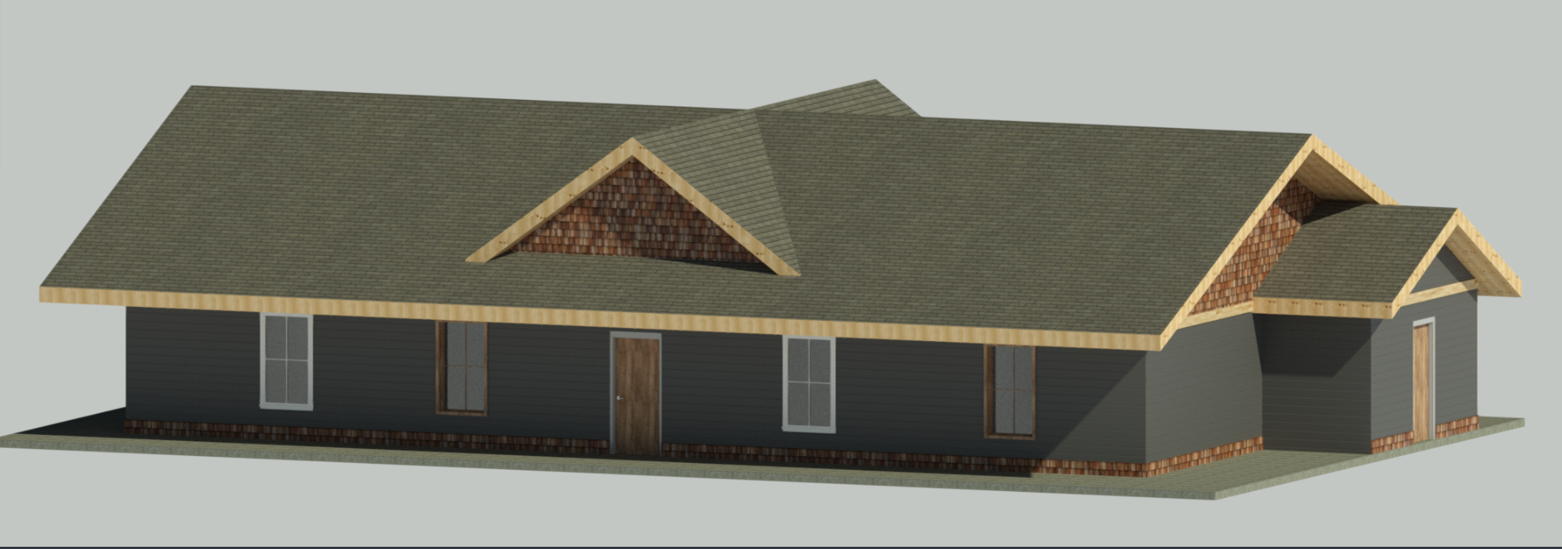
Figure 9: Front of House Render

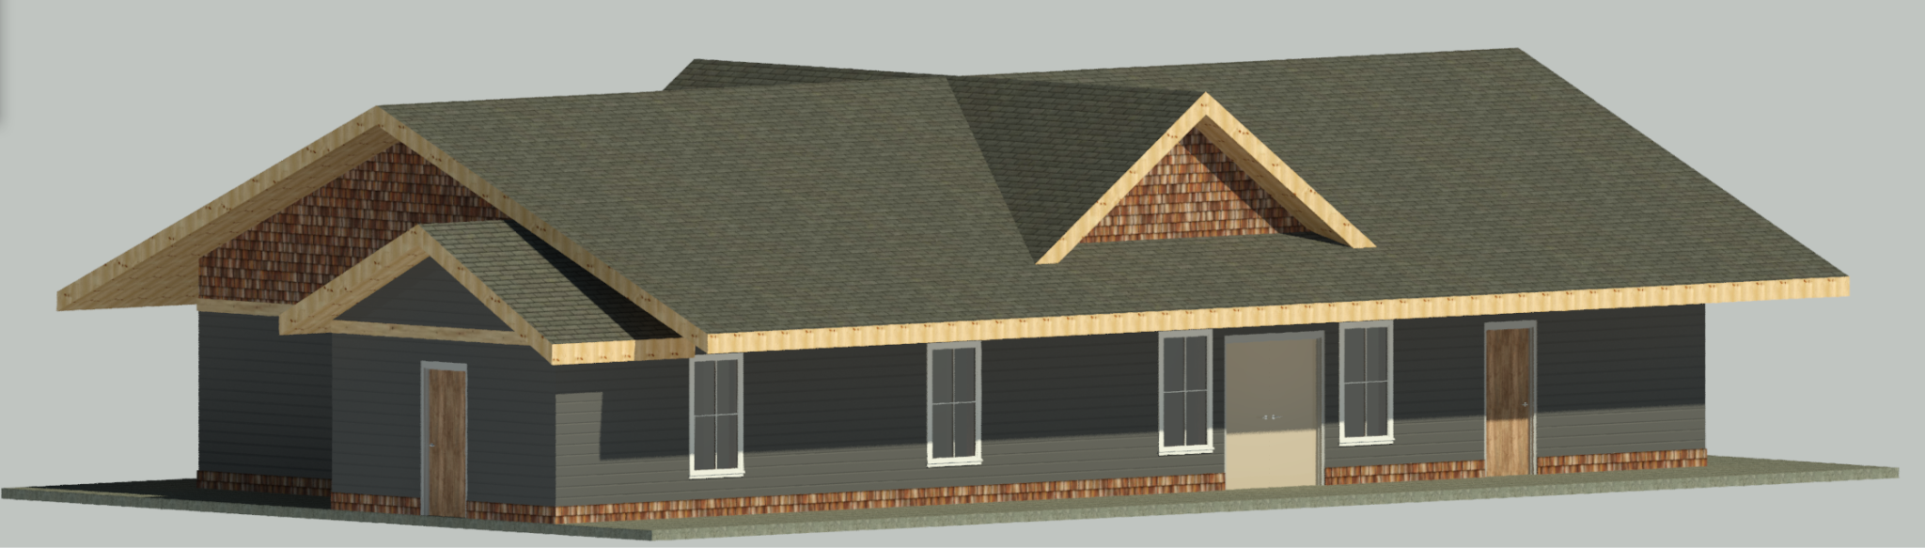
Figure 10: Front of House Render
With the house virtually created, complete with designated material types and spaces, the team proceeded to input the electrical loads that the house and PV system would experience. Autodesk Revit offers the capability to assign specific lighting, appliance, and HVAC loads to each room and space in the home. Each space was designated with its specific usage type and the average occupancy load it would have. This feature enables the program to determine which spaces, such as living rooms and bedrooms, require cooling while disregarding closets and unoccupied areas.
Revit utilizes the USDE's EnergyPlus engine to simulate the electrical, heating, and cooling loads for the house. It relies on location and weather data to simulate the house under average monthly conditions. Figure 4 displays the closest weather station accessible to Revit, which is within 5 miles of the home's location and provides excellent weather and condition data. Accuracy in specifying the location is crucial to minimize errors resulting from imperfect weather conditions. The results of the energy model are presented in Appendices XVI through XIX.
Appendix I showcases the monthly energy usage chart for the cabin, which is the most significant metric for validating the chosen design. The system must supply equal or more energy than the estimated amount to ensure the cabin does not rely on grid power. Due to technical issues, HVAC and appliances are grouped under the general category of "interior equipment." Electrical and HVAC loads were inputted based on provided specifications, assuming usage times and types in line with a residential home. The chart indicates that the PV system needs to supply at least 1400 kW of power per month to meet the simulated electrical loads. The yearly total energy consumption is calculated to be 15,500 kW. Based on this output, the team's chosen design has been validated as capable of supplying sufficient energy to the home.
Appendix XVIII presents the resulting heating and cooling loads for the home, which directly reflect the home's efficiency. Heating and cooling account for the majority of the cabin's electricity consumption. The simulation also considers heat loss from the home using the assigned material types. Air exchanges, penetrations, exterior door openings, and weather data are factored in to estimate the heating and cooling load. Revit establishes a set temperature point of 70 degrees to determine the amount of thermal energy needed to maintain a constant temperature in the simulation. It's important to note that energy usage can vary significantly depending on the occupants' preferred temperature settings. Based on these preliminary results, the PV system will meet the usage requirements of the HVAC system, even during peak heating and cooling loads. For details on heating and cooling loss through the home, please refer to Appendix XIX.
To further validate the design, the team will continue updating and refining the model to accommodate any changes in the PV system or cabin design. Next semester, as a significant part of this effort, the team plans to model the PV system in conjunction with the energy model to refine and simulate how the PV system will handle load changes and optimize any modifications to the home design that would result in meaningful energy savings.

5.3. Implementation Plan

5.3.1. Preliminary Steps
In order to implement the final design, several factors must first be considered. As previously mentioned, a group of students from ME 451 Renewable Energy began this project, and provided the current team with data sheets and some other additional information, including a preliminary Bill of Materials; the majority of this information is located in Appendices I-IV. Once the information was transferred and deliberated upon, as well as the project requirements and customer needs, the team began researching solar PV systems, and contacted the client Steve Winiecki. Several deliverables were completed regarding the initial stages of design, including flow charts, a QFD, and schedules. The team then conducted concept generation, utilizing Pugh charts and decision matrices; a final Bill of Materials was also constructed, as previously mentioned. Presentations deliberating information and team progress were delivered to ME 476c capstone students, as well as Dr. Carson Pete. Prototyping occurred throughout and after the decision making phase, with digital prototyping being the most prominent.

5.3.2. Implementation Procedure
The team is now preparing for the implementation stage of the project, where the focus will now be gathering materials, site location visits, and actual construction of the system. The team will be in close contact with the client in order to ensure the logistics of the aforementioned focal points.

5.3.2.1. Client Contact/ Budget Considerations
In order to ensure product quality and logistics, the team will need to maintain contact with the client. Confirming client needs will be the first priority in this regard, followed by establishing a budget, creating good meeting times for site visits, delivery of materials, and finally construction.

5.3.2.2. Material Sourcing
Materials will be sourced once the client confirms the budget and final design. Material sourcing is entirely contingent upon solidifying a budget for the team, as a majority of the budget will be towards material. As previously mentioned, a full Bill of Materials for the final design is available in Appendix xx. It should be noted that dealer prices may be obtainable for many of the necessary materials.

5.3.2.3. Implementation Costs
Generally speaking, the vast majority of cost will be associated with material sourcing. However, other considerations such as permitting, transportation, and logistical needs will require funding. In retrospect to this, a small portion of the budget will be allocated to implementation costs, whereas a large portion will be in material sourcing.

5.3.2.4. Scheduling
In order to complete the project successfully, and with fair treatment to the client and team members, good scheduling practices must be undertaken. Below is a preliminary schedule for major tasks upcoming for the Fall 2023 semester, when the implementation process will commence. Note, this schedule may be subject to change depending on factors within the team, client, local government, and material manufacturers.
- Testing Plan …………………………………………………………………………………………………..9/2023
- Operation/Assembly Manual …………………………………………………………………………….11/2023
- Final CAD Packet …………………………………………………………………………………………12/2023
- Final Report ………………………………………………………………………………………………….12/2023

6. Conclusion

6.1. Report Summary
The contents of this report include all up to date, present information available to the team. Topics within the project including background, requirements, testing procedures, risk analysis and mitigation, and designs selected are all covered in depth within this report. Throughout the semester, the team was able to encapsulate each of the mentioned topics within this report, and it will be used and referenced throughout the duration of the project.

6.1.1. Project Description
As a brief summary of the project, the team is tasked with designing, optimizing, and implementing a solar photovoltaic system, capable of both grid tied and off grid energy generation. The critical requirements of the project are as follows:
- Cost Efficient
- Large Storage System
- Safe to Operate
- Solar Generation Heavy
- Reliable/Adaptable Design
- Minimal Grid Feedback

6.2. Final Solution Proposal - Full System Design 2
Full system design 2 is based on maximizing the cost efficiency of the design. It incorporates a higher wattage panel, and a median sized battery system. The focus of this design is to gain the lowest cost per wattage for both energy storage and generation. A decision matrix for this design is located in Appendix XV. The pros and cons of this system are as follows:

Pros:
- Cost - Both the initial and long term costs of power are much lower
- Quality - The overall quality of the system is acceptable
- Capacity - The overall capacity for renewable power usage is moderately high

Cons:
- Reliability - Certain weather conditions or product quality may inhibit power generation more than a more expensive panel
- Warranty - The warranties included with this design are slightly more limited
- Durability - The products may be less durable over an extended period

*As previously stated, a full Bill of Materials for this design is located in the appendices*

7. References
[1] “About Building Energy Modeling,” Energy.gov.
https://www.energy.gov/eere/buildings/about-building-energy-modeling

[2] “EnergyPlus,” Energy.gov.
https://www.energy.gov/eere/buildings/articles/energyplus
[3] “Building Energy Modeling: HVAC Design and Operation Use Case,” Energy.gov, 2017.
https://www.energy.gov/eere/buildings/articles/building-energy-modeling-101-hvac-design-and-operation-use-case
[4] “Building Energy Modeling 101: Inherent Performance Rating Use Case,” Energy.gov.
https://www.energy.gov/eere/buildings/articles/building-energy-modeling-101-inherent-performance-rating-use-case.
[5] T. Rakha and R. El Kontar, “Community energy by design: A simulation-based design
workflow using measured data clustering to calibrate Urban Building Energy Models (UBEMs),”Environment and Planning B: Urban Analytics and City Science, vol. 46, no. 8, pp. 1517–1533, Sep. 2019, doi: https://doi.org/10.1177/2399808319841909.
[6] “Camp Verde, AZ Electricity Rates,” Electricity Local.
https://www.electricitylocal.com/states/arizona/camp-verde/.
[7] “Clean Energy Innovation – Analysis,” IEA.
https://www.iea.org/reports/clean-energy-innovation
‌[8] “Renewable Energy Trends 2020,” USDA
https://www.usda.gov/sites/default/files/documents/renewable-energy-trends-2020.pdf
[9] Palmetto, “Everything You Need To Know About The Solar Tax Credit,” palmetto.com.
https:/palmetto.com/learning-center/blog/everything-you-need-to-know-about-the-solar-tax-credit
‌[10] “Credit for Solar Energy Devices | Arizona Department of Revenue,” azdor.gov.
https://azdor.gov/forms/tax-credits-forms/credit-solar-energy-credit
[11] “Solar Home Grid-Tie System Sizing Part 1: Using a Utility Bill,” SolarPanelStore.
https://www.solarpanelstore.com/blogs/solar-panel-store-blog/solar-home-grid-tie-system-sizing-part-1-using-a-utility-bill.
[12] B. Zito, “The Most Efficient Types Of Solar Panels Of 2023,” Forbes Home, Apr. 28, 2023.
https://www.forbes.com/home-improvement/solar/most-efficient-solar-panels
[13] C. Crail, “Everything You Need To Know About Solar Batteries,” Forbes Home, Apr. 27,
2023. https://www.forbes.com/home-improvement/solar/what-is-a-solar-battery

[14] N. Gerhardt, “Here’s What You Need To Know About Ground Mounted Solar Panels,”
Forbes Home, Apr. 27, 2023. https://www.forbes.com/home-improvement/solar/ground-mounted-solar-panels

[15] J. Poole, “Microinverter vs String Inverter: Which is Right For Your Solar System?,”
Solar.com, Feb. 14, 2017. https:/www.solar.com/learn/micro-inverter-string-inverter-comparison-solar-equipment
‌[16] “What Components are Typically used in an Off-Grid Solar Power System?,” Northern
Arizona Wind & Sun. https://www.solar-electric.com/learning-center/what-components-typically-used-off-grid-solar-power-system/

[17] “Solar Racking: Best Solar Panel Mounts in 2021,” Unbound Solar, Jan. 01, 2021.
https://unboundsolar.com/blog/best-solar-panel-mounts

[18] “Radian Series Inverter/Charger GS4048A GS8048A Installation Manual.”
https://s3.amazonaws.com/zcom-media/sites/a0i0h00000KyCXiAAN/media/mediamanager/OutBack_Radian_4048A_8048A_Inverter_manual.pdf

[19] “GridZero Mode.” OutBack Power Systems
https://www.outbackpower.com/downloads/documents/appnotes/gridzero_app_note.pdf
‌[20] “Solar inverter buyer’s guide,” Solar Reviews.
https://www.solarreviews.com/blog/what-are-solar-inverters
‌

8. Appendices

Appendix I: Original System Spec Sheets
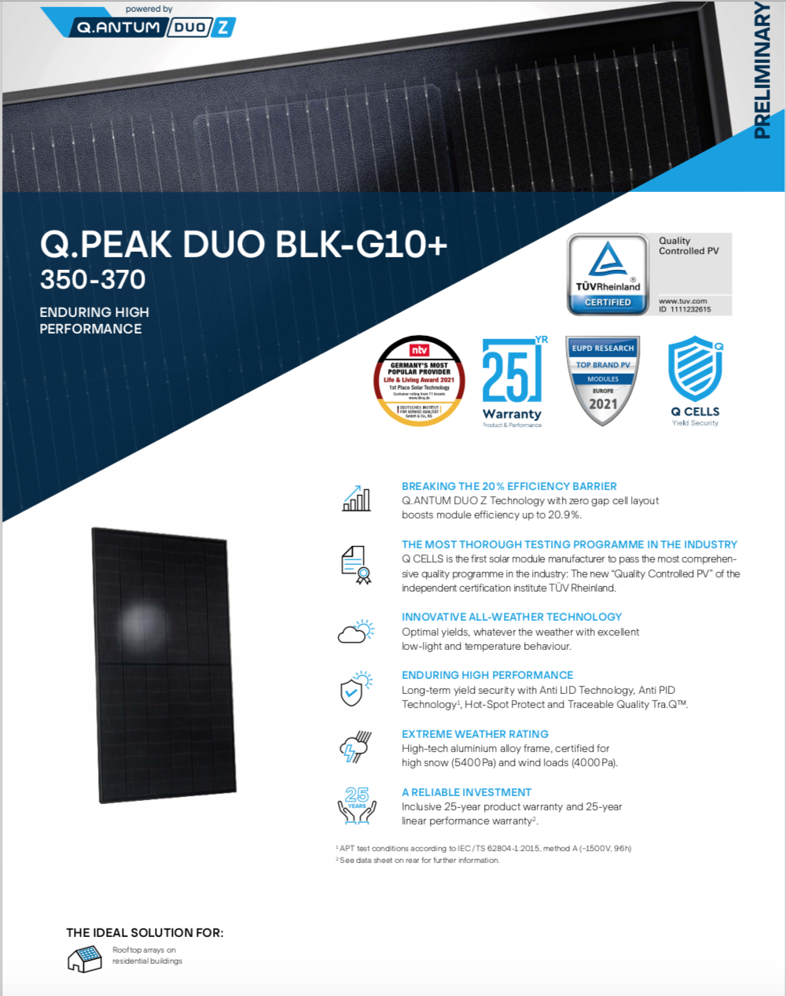

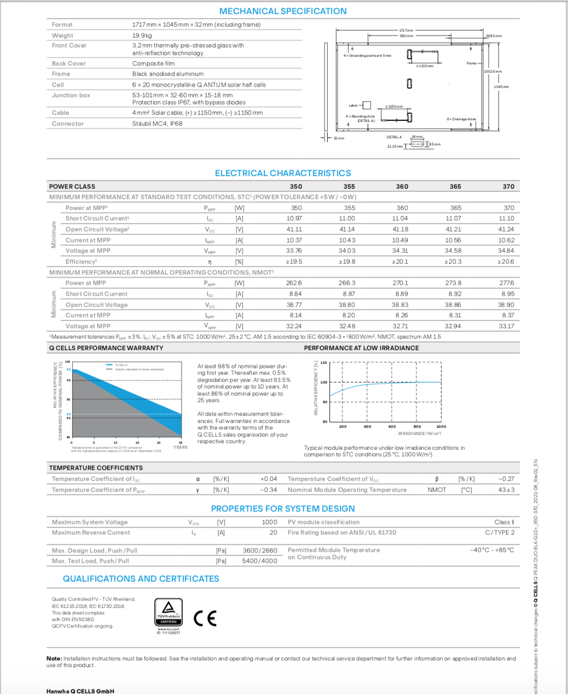

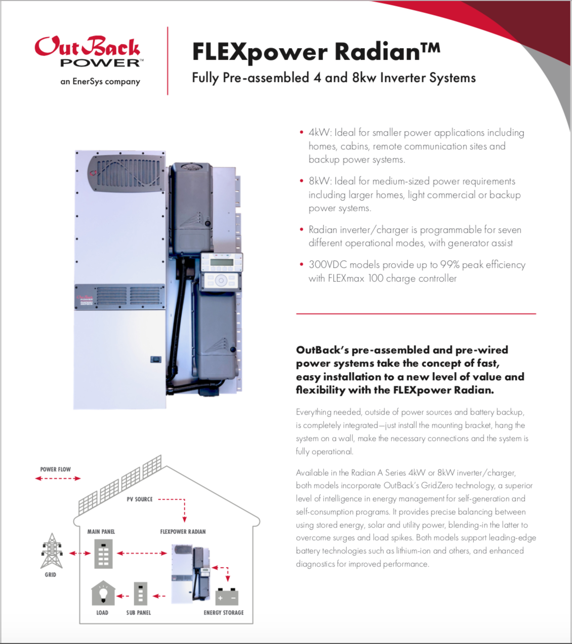

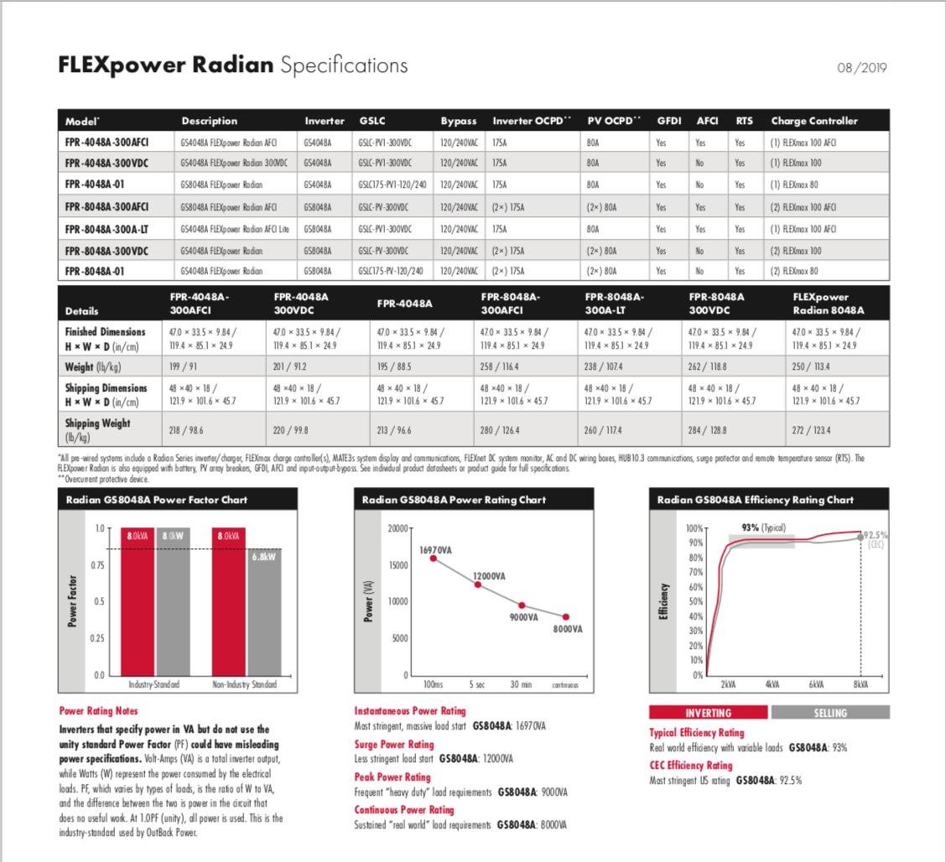

Appendix II: Original Bill of Materials
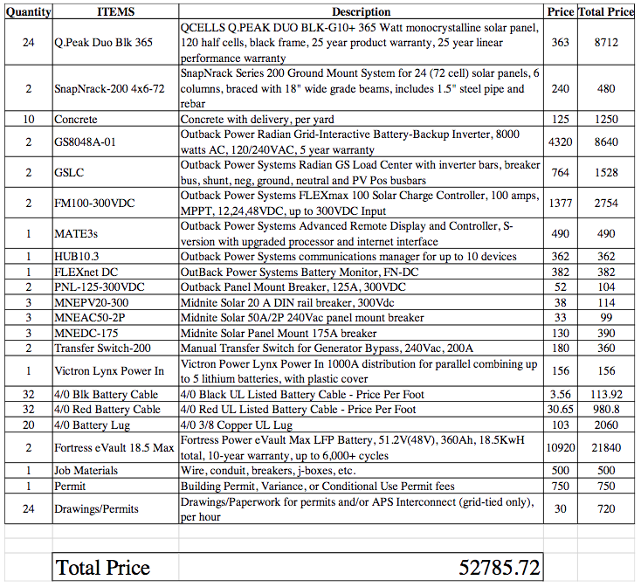

Appendix III: Original System PVWatts Report

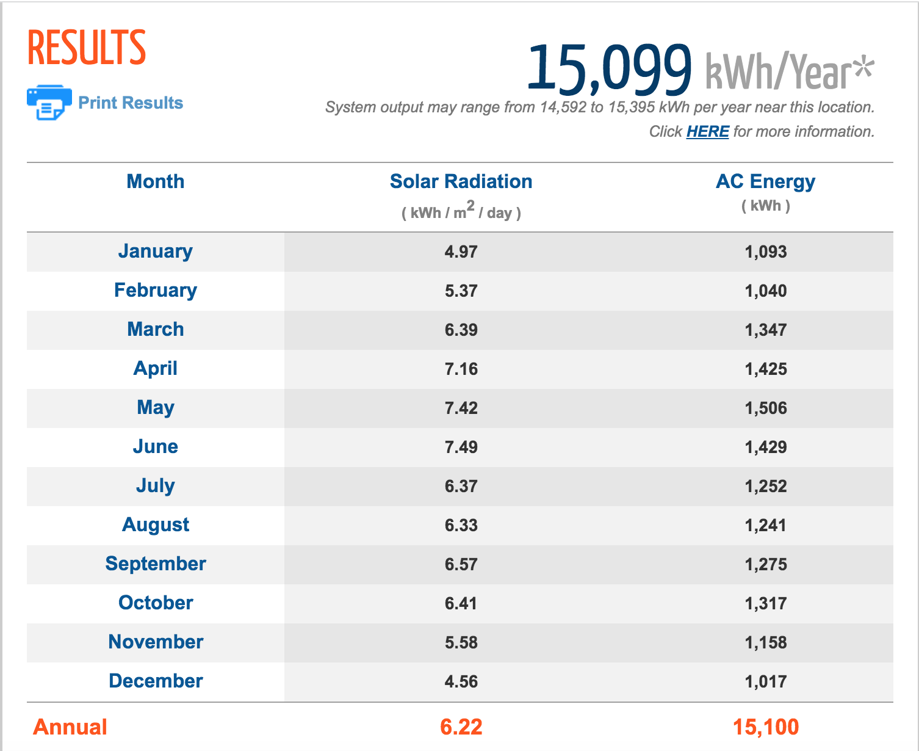

Appendix IV: Original System Quotes
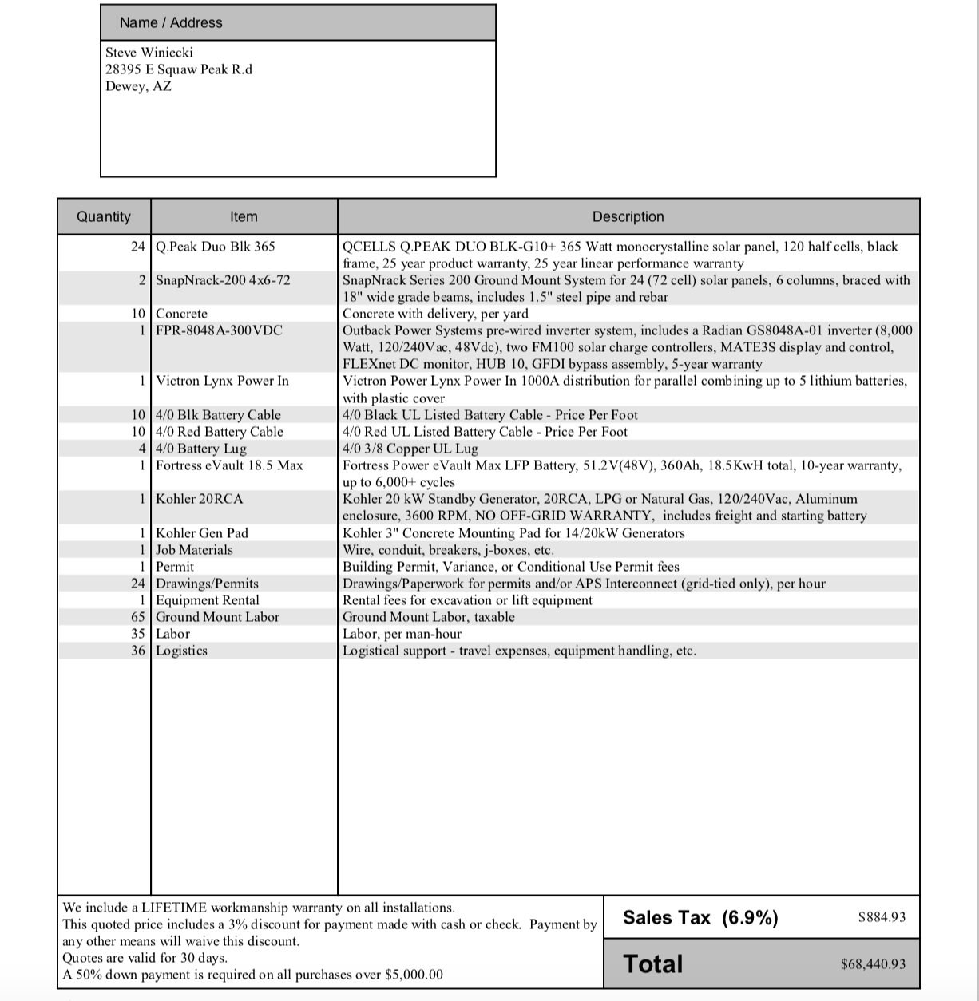
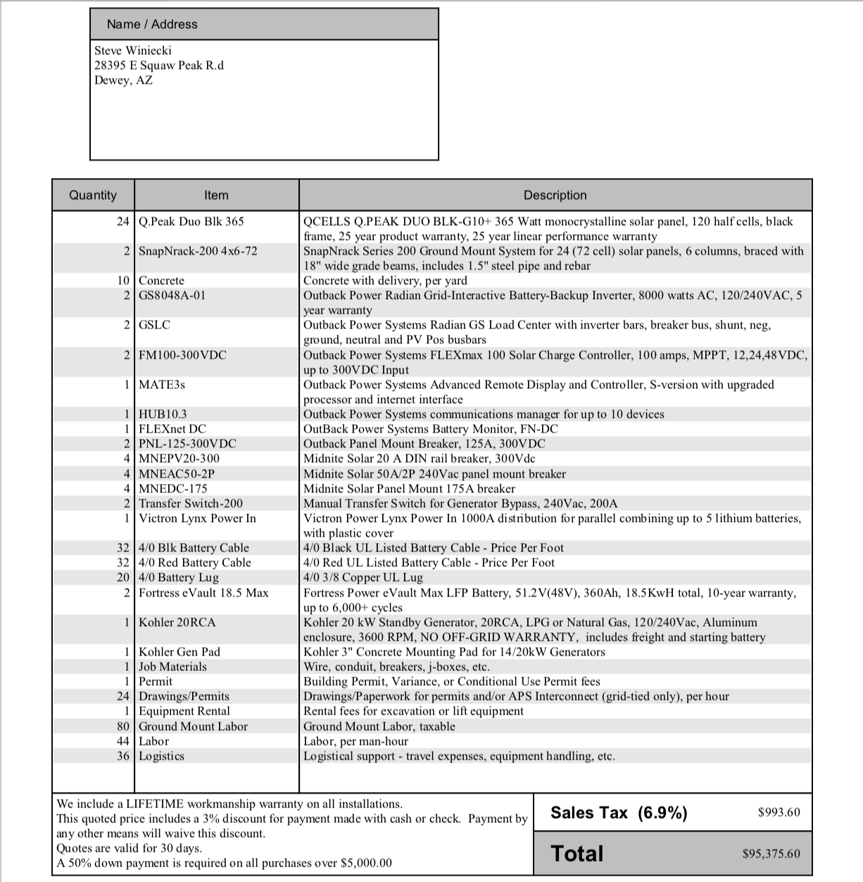

Appendix V: Renewable Energy Systems Pugh Chart

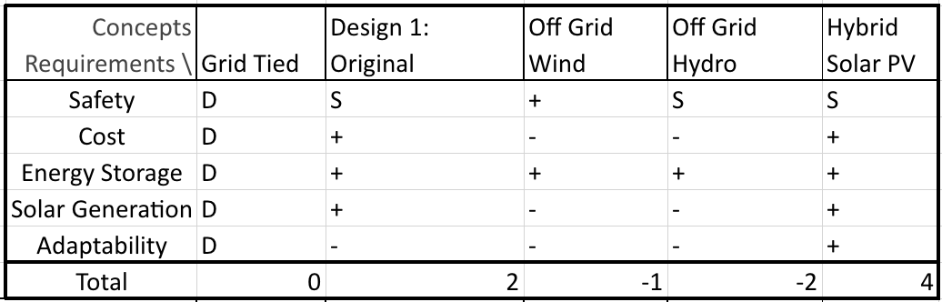

Appendix VI: Back-of-the-Envelope Calculations

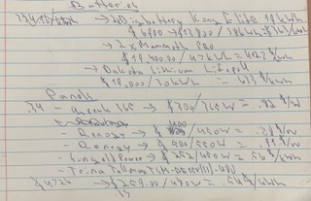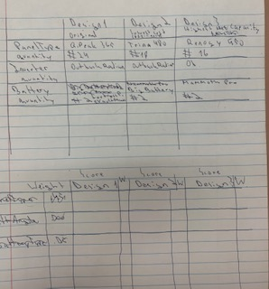

Appendix VII: Black Box Model

Appendix VIII: Work Process Chain Diagram
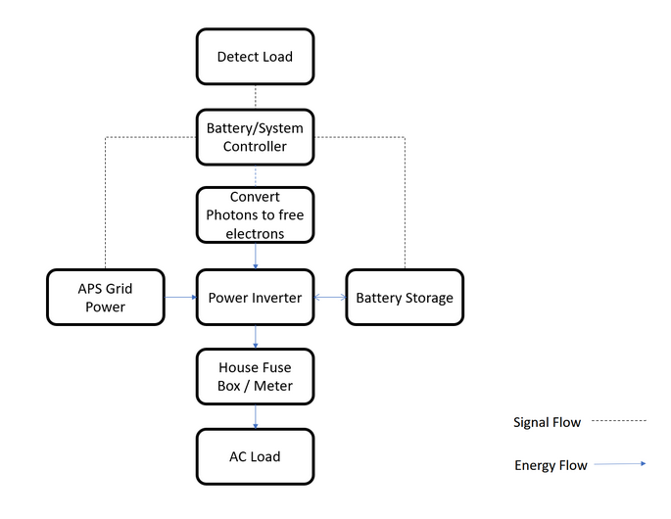

Appendix IX: House of Quality
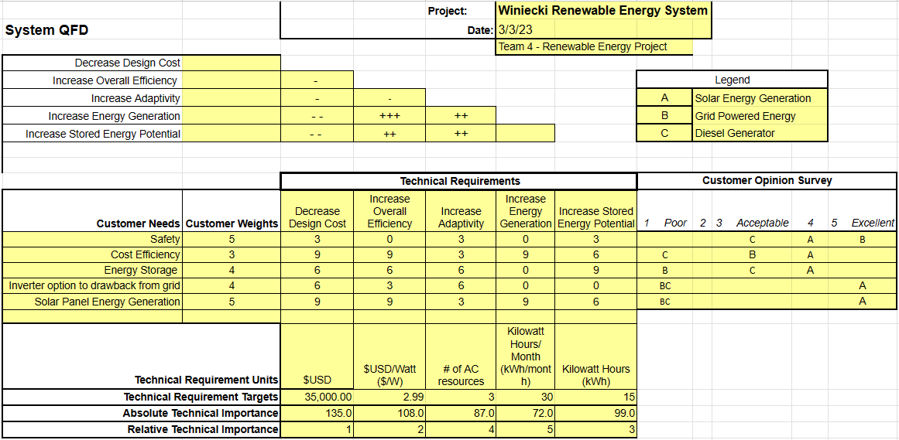

Appendix X: Detailed Electrical Diagram Displaying Inverter
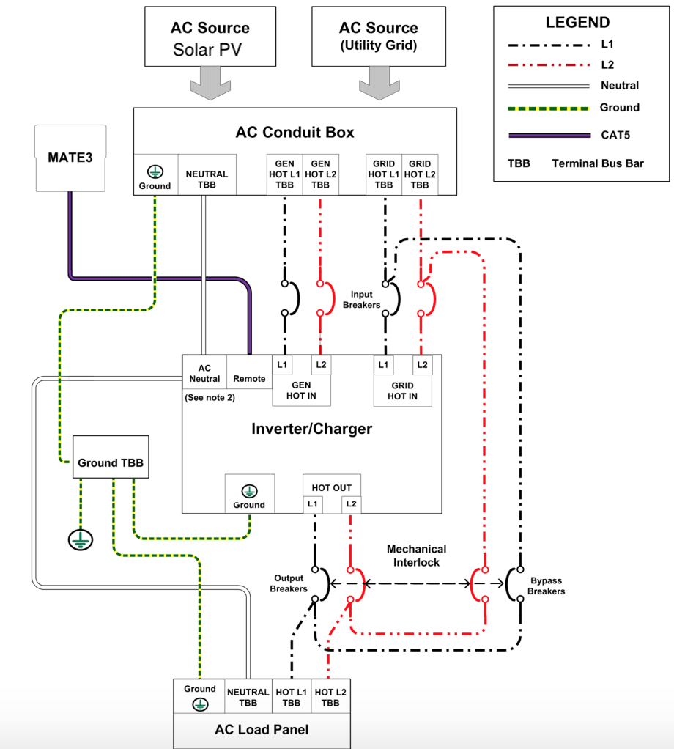

Appendix XI: Final Design Bill of Materials
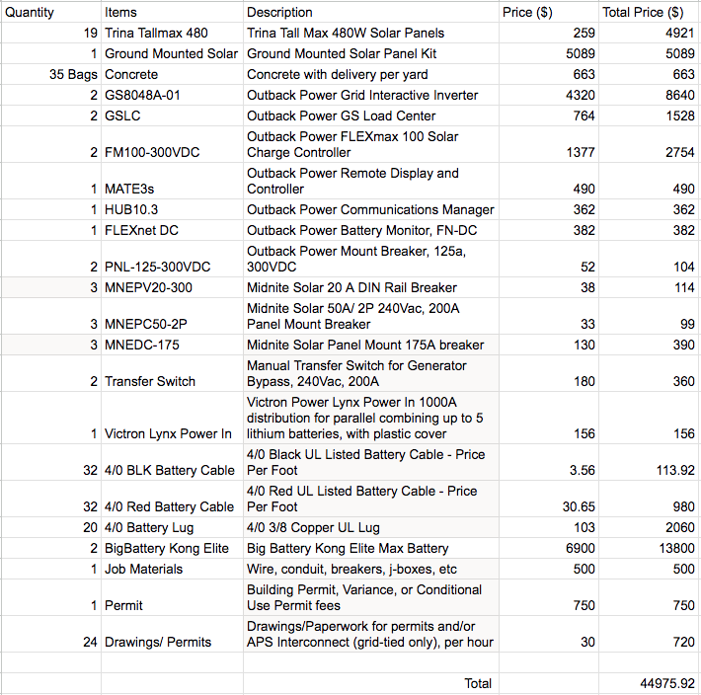

Appendix XII: Trina Tallmax Spec Sheet
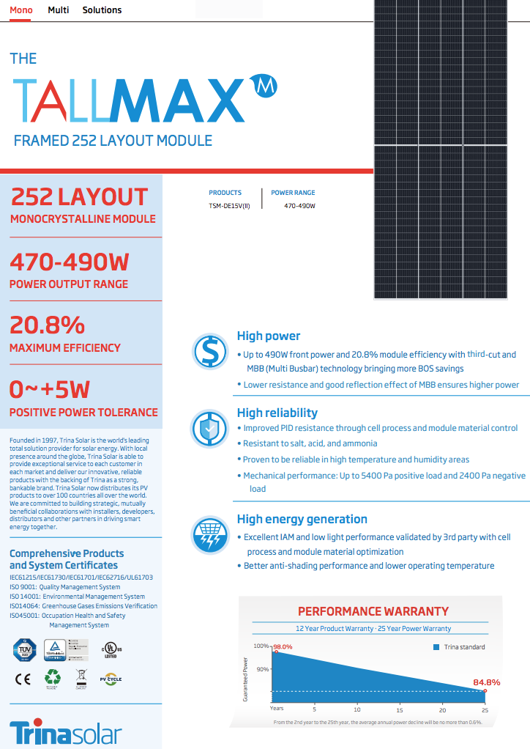
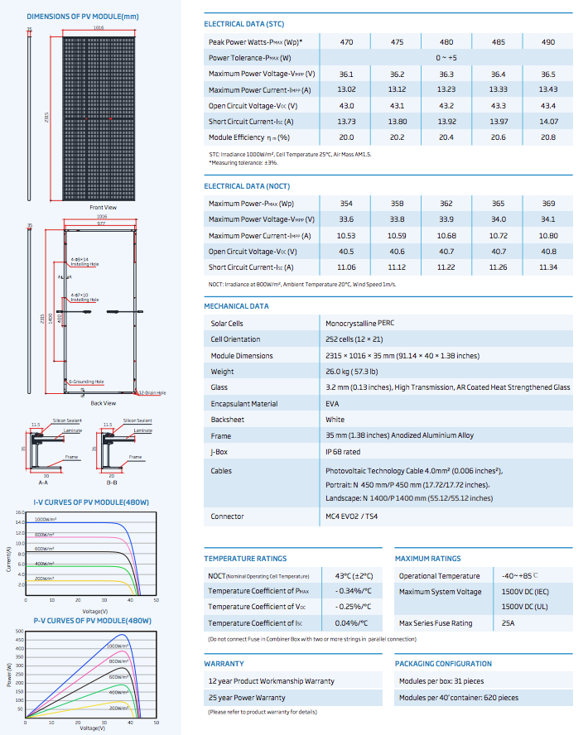

Appendix XIII: FMEA for Design 2
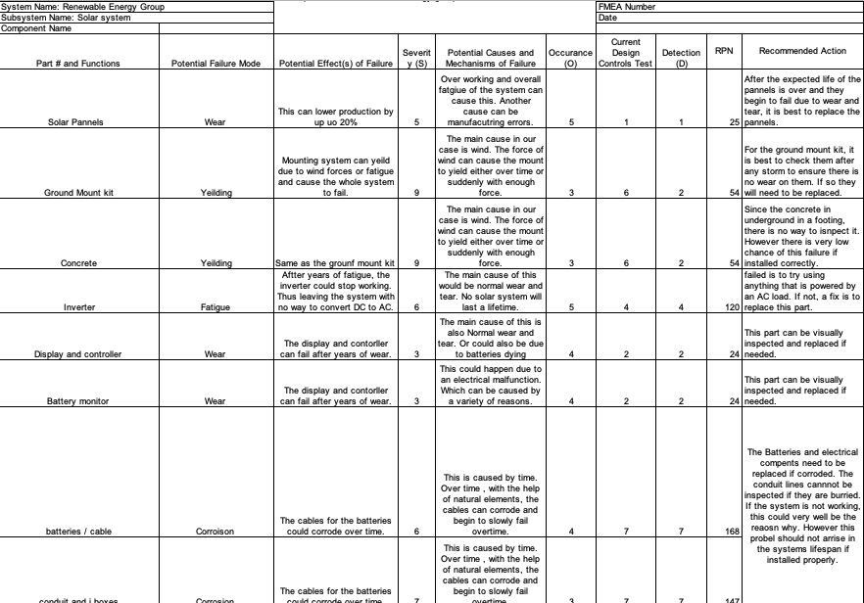

Appendix XIV: Select Prototyping Photos
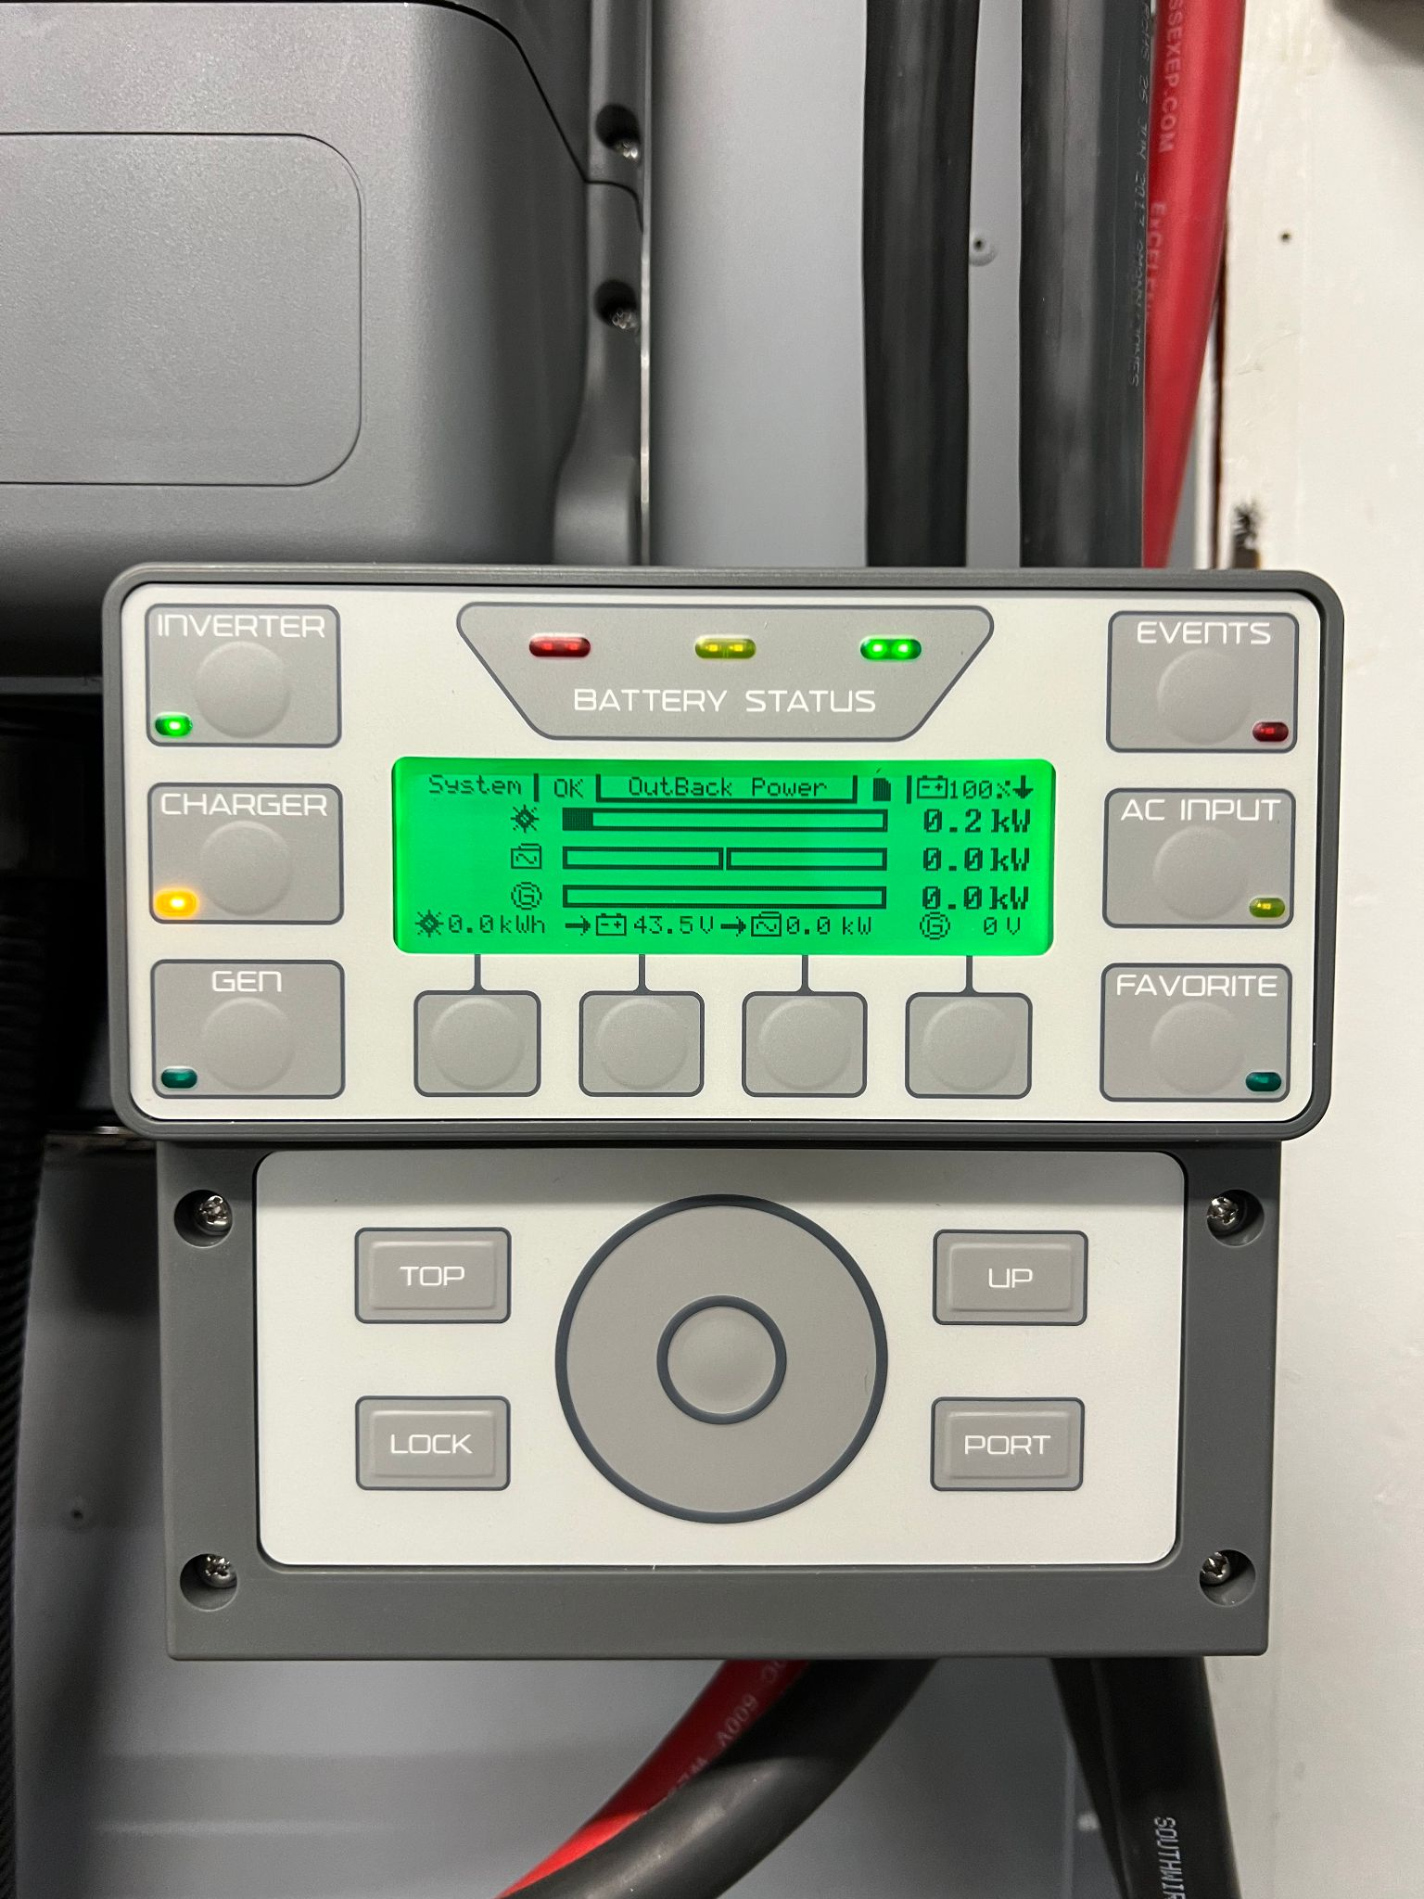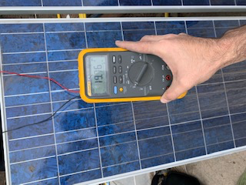
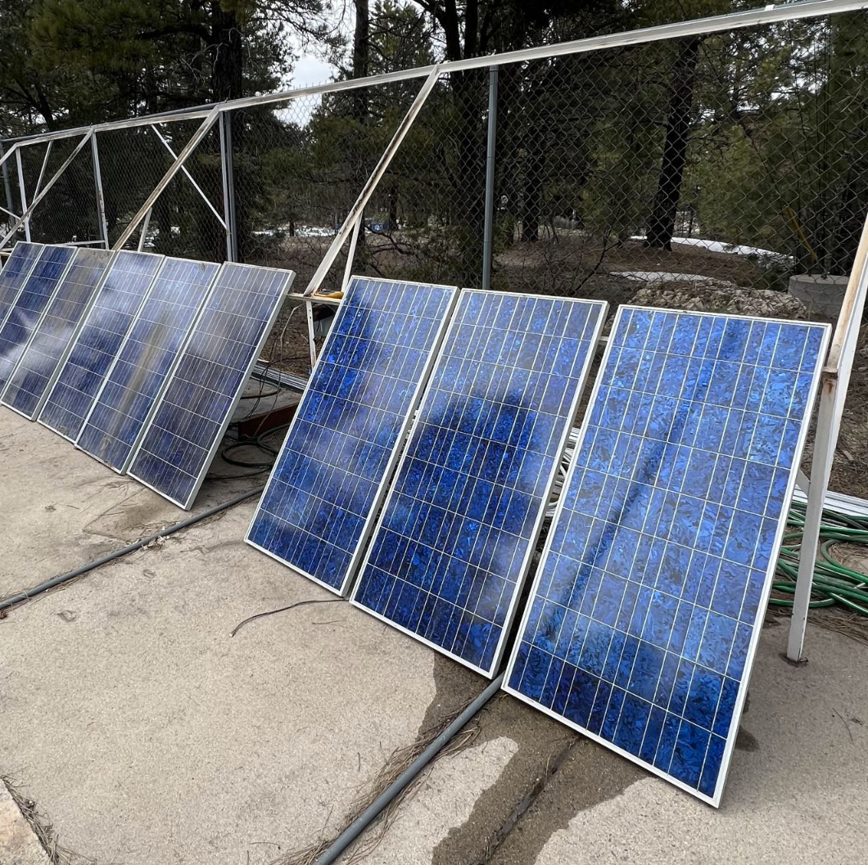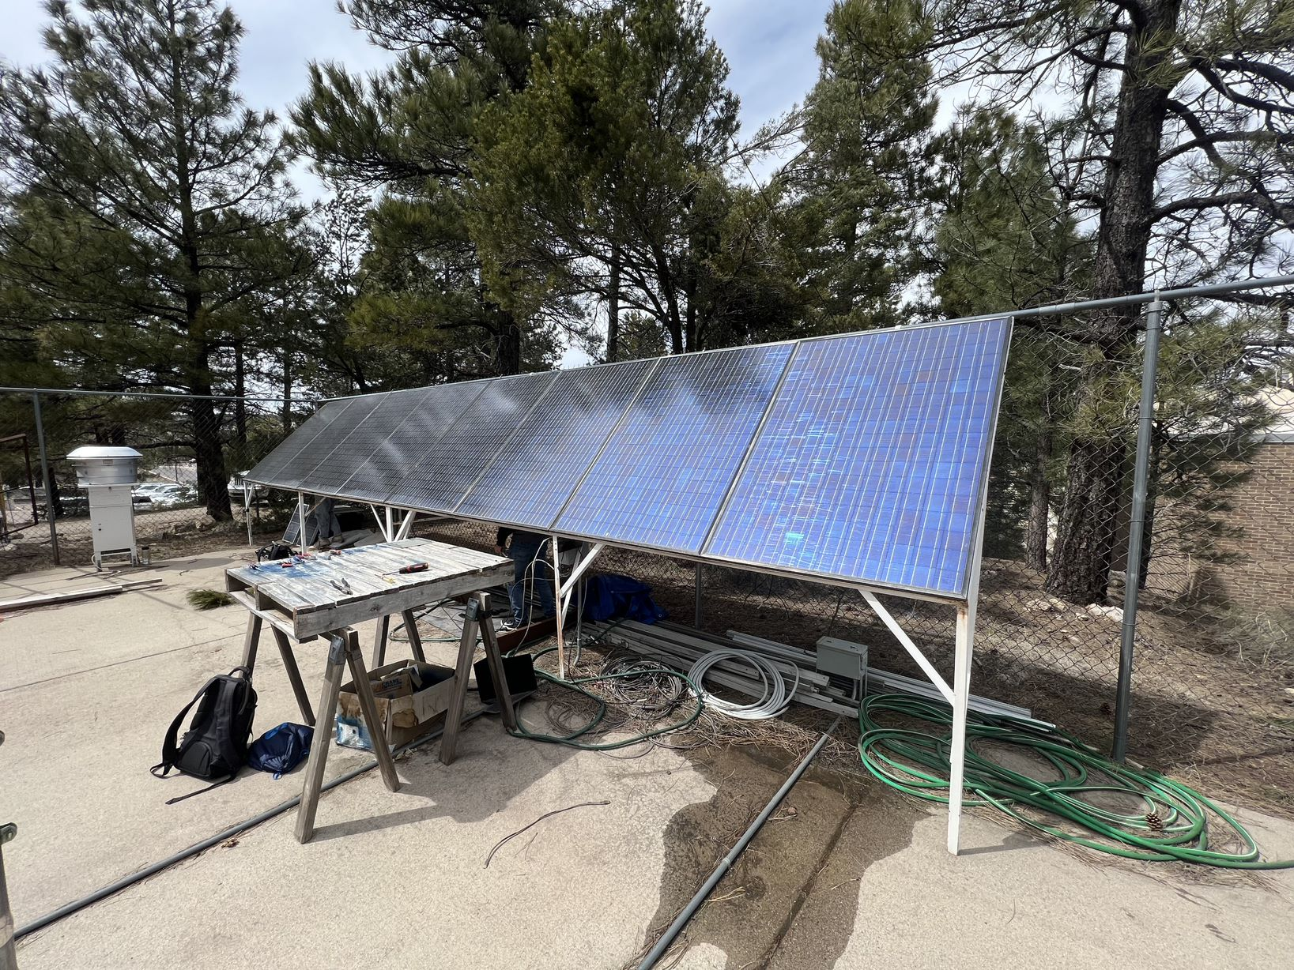

Appendix XV: Final Design Decision Matrix
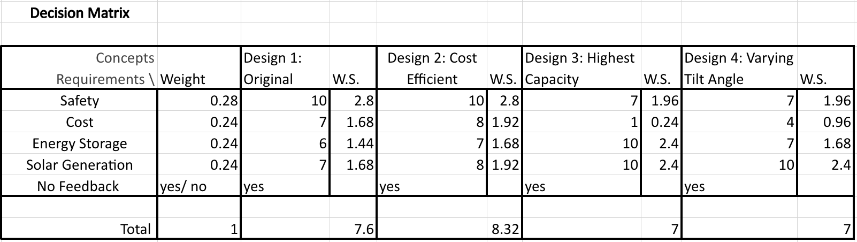

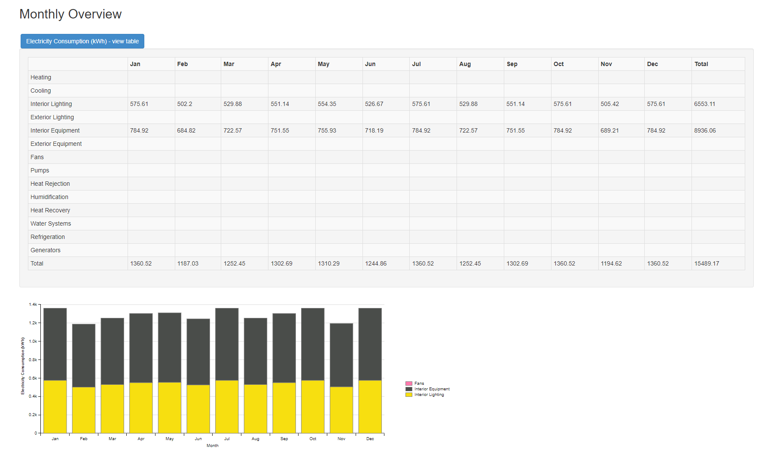
Appendix XVI: Energy Model Electricity Consumption Results

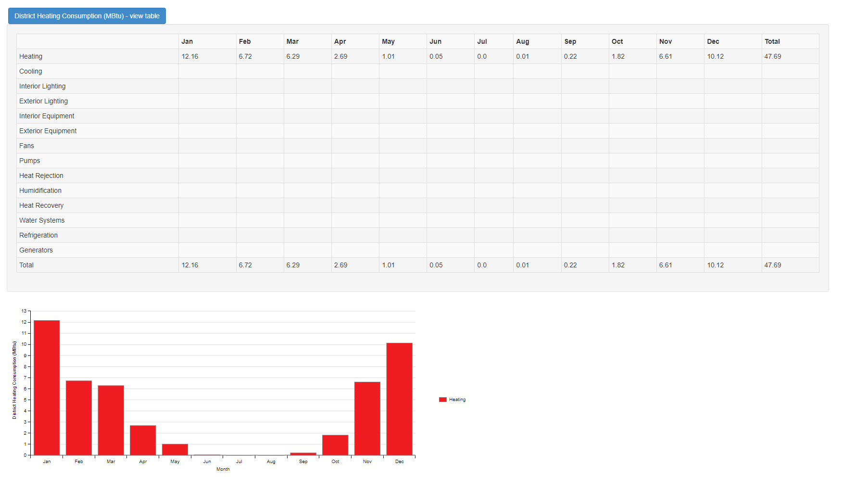
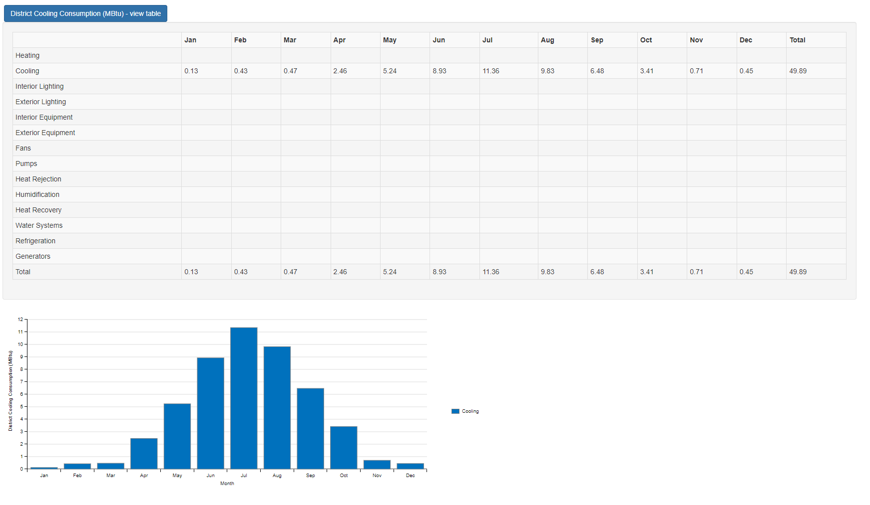
Appendix XVIII: Cooling & Heating Consumption Results

Appendix XIX: Heating and Cooling Load Model Results

